Dane County’s Teen Newspaper

Simpson Street Free Press

Curriculum Guide – Summer Special Issue 2010

Look for our vocabulary crosswords, geography quizzes, and other learning tools launching online soon!

Science, page 1 (continued on page 24) and page 28:
Have your students read the “mysterious animal” article on the front page and discuss the following questions:
- What is a “pizzly” or “grolar” bear?
- How did this bear come to exist?
- Why do scientists think bears are venturing out of their home range?

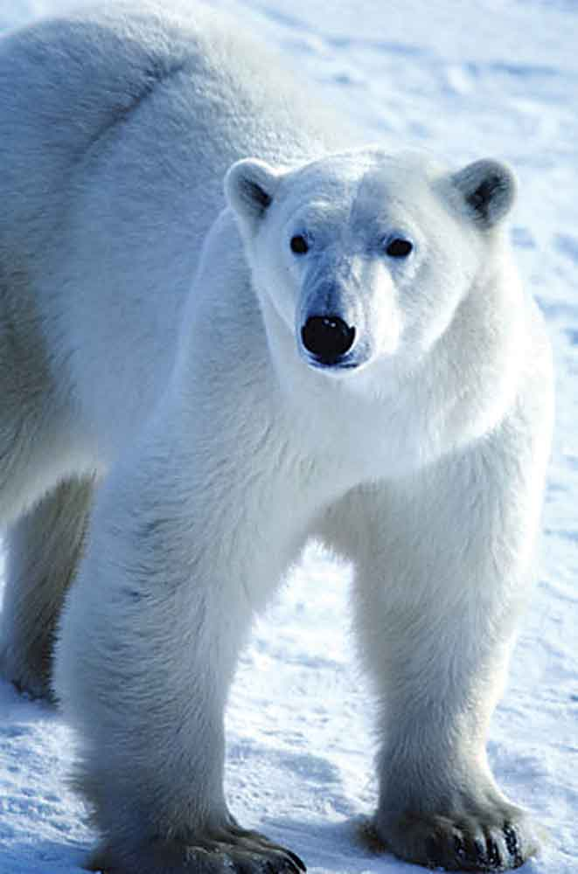
Also turn to the back page and read the Wisconsin’s Birds of Prey feature series. Compare and contrast the different types of predatory birds we’ve covered in this issue.

Geography, pages 2-3:
- What is causing warmer ocean temperatures?
- How do the warmer ocean temperatures affect ocean life?
- Why is it difficult for scientists to understand Himalayan glacial melt?
- What is the role of the IPCC? Why is it so important for their estimates to be accurate?
- What is unique about the Sinornithosaurus dinosaur?
- What new discovery led scientists to believe that Neanderthals were capable of symbolic thinking? What is symbolic thinking?

Energy & the Environment, pages 4-5:
- What causes a dead zone in the ocean?
- How are scientists trying to use algae blooms as an energy source? Why is this idea somewhat controversial?
- Compare and contrast the new electric cars that will be available soon. What new features and technology make these cars unique?
- What is cellulosic ethanol?
- What are some pros and cons of using ethanol for fuel?

Science, pages 12-13:
- Which species of tree frogs live in Wisconsin? Compare and contrast these species.
- How do tree frogs stick to surfaces?
- What new species of spider was recently discovered?

We often write about invasive species in the Simpson Street Free Press. Do your students remember the definition of invasive species from past issues or other research? Discuss the different types of invasive species and why they are bad for ecosystems. How can we prevent invasive species from spreading?

Animal Watch, pages 14-15:
- Why is a lack of genetic diversity within an animal population a bad sign?
- What are some theories about why more brown-and-white pandas are appearing?
- How do scientists track the migration of Arctic terns? What is the longest distance a tern has ever traveled?
- List some unusual characteristics of the platypus.
- What are some reasons for the comeback of trumpeter swans and ospreys in Wisconsin?

History, page 18:
Have your students read the special section on page 18 about Negro League baseball. Who were the stars of the Negro League? How did the Negro League make an impact on American history?

Space Science, pages 26-27:
- How do stars form? What happens when they collapse?
- Why is the Steins asteroid shaped like a diamond?
- What is the Big Bang theory?
- Discuss the different types of storms that occur on other planets. Why do these storms happen?

Geography
On a world or U.S. map, locate the following countries, areas, or landmarks mentioned in this issue of the Simpson Street Free Press.

Page 1: Arctic Ocean
Simpson Street Free Press Literacy Initiative
Book Talk, pages 10-11:

- If any of your students have read the books we’ve reviewed, have them share their thoughts about the book.
- Have students write their own review of books on our “Classic 30” lists and submit it to us for possible publication in the next issue of the Simpson Street Free Press. Published students receive $25 gift certificates to a local bookstore.
- Let us know what your school’s book club is reading! We want to feature your book club in the next issue of the Simpson Street Free Press.
- Encourage students to join the 6-7-8 Club – the official online book club of the Simpson Street Free Press! Students can join by visiting our website, www.simpsonstreetfreepress.org.
Page 2: Himalayan Mountains
Page 3: China
Page 4: Gulf of Mexico
Page 12: Israel; Jordan
Page 14: Greenland; Iceland
Page 14: Zambia; Tanzania
Page 17: Afghanistan

Teachers:
Please call us if you’d like more papers for your
classroom.

We love to hear from our readers. Have your
students pick their favorite article and write a
short letter to the reporter. Letters can be mailed
or e-mailed to us. Thanks to all of you. Keep up
your great work!

Contact:
Jim Kramer
P.O. Box 6307
Monona, WI 53716
(608) 223-0489
ssfp@itis.com

